UI Research

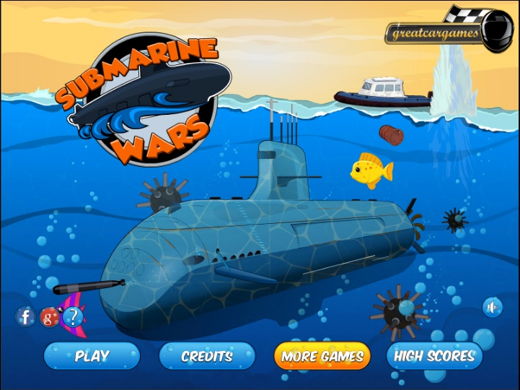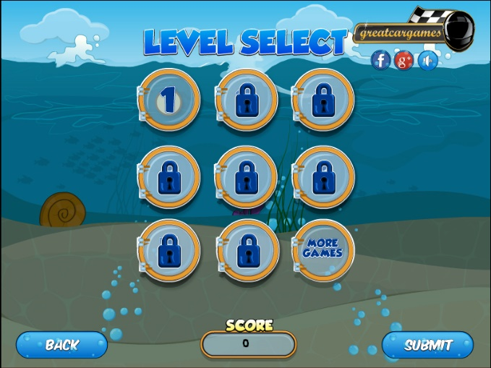

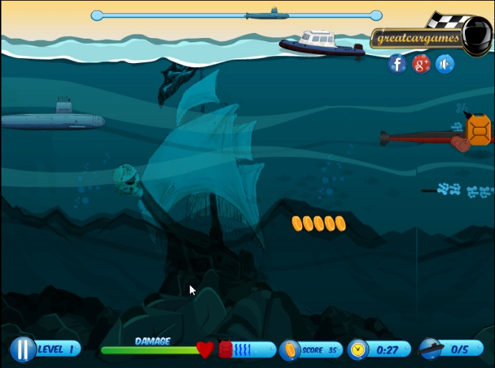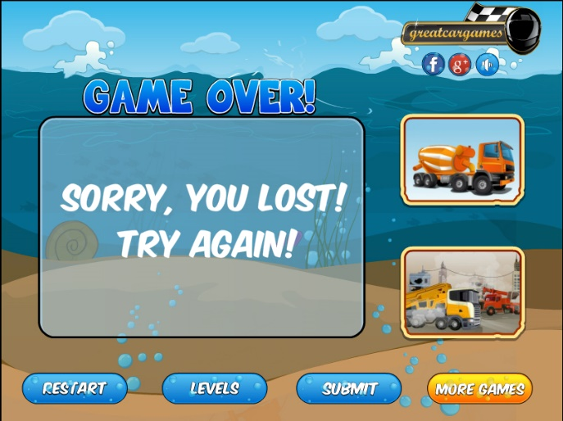

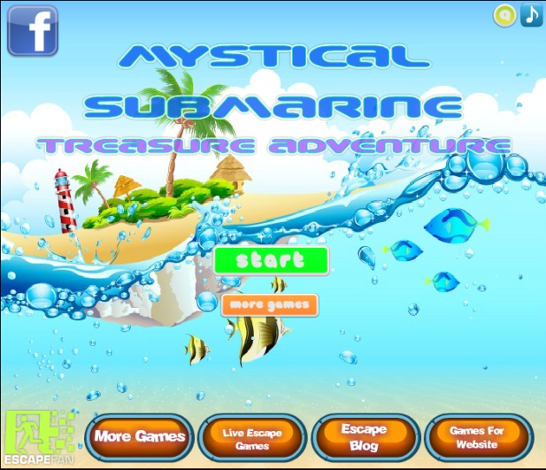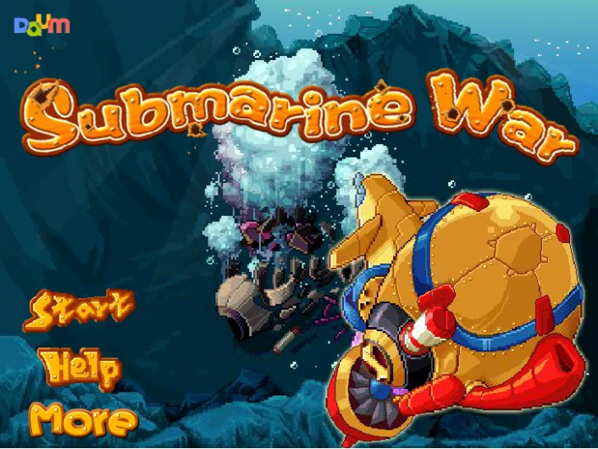

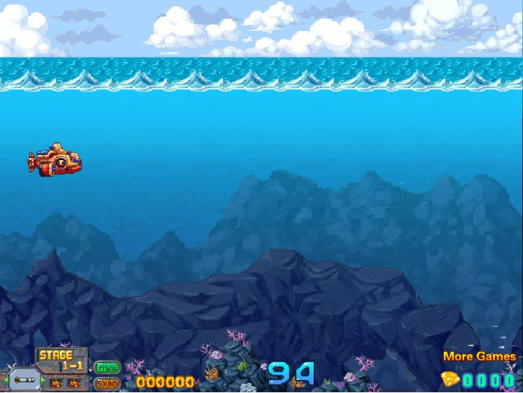

Out of all the games I have played, they all share one thing in common, that all of the User Interface is cuttlered on the bottom of the screen. There is no ‘Setting’ button to access the games other various buttons as it is more player efficent to have everything displayed on a singlar screen it seems.

The UI design also seems to share the same theme of the games either as well as being visually appealing to attract a certain target audience and fitting with the developers choosen artstyle for the game.

As previous stated in my colour theory document, some games use colours to visually communicate to the player which are enemies and what aren’t. Such as the black submarines.

**References:**

Masoko (2013). *Submarine War*. [online] NewArcade.net. Available at: http://www.newarcade.net/game/8139/Submarine-War.html [Accessed 6 Mar. 2018].

gamolition (2014). *Submarine Wars*. [online] Kongregate. Available at: https://www.kongregate.com/games/gamolition/submarine-wars [Accessed 6 Mar. 2018].

ainarsa (2015). *Mystical Submarine Treasure Adventure*. [online] Kongregate. Available at: https://www.kongregate.com/games/ainarsa/mystical-submarine-treasure-adventure [Accessed 6 Mar. 2018].